**Case Study**

The main list view is this:

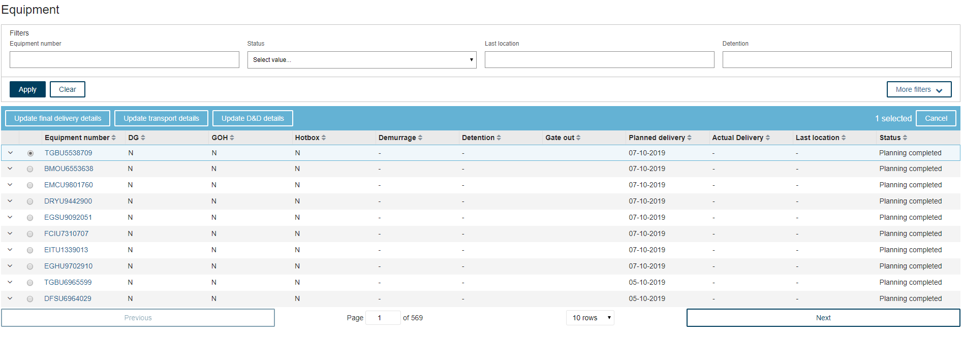

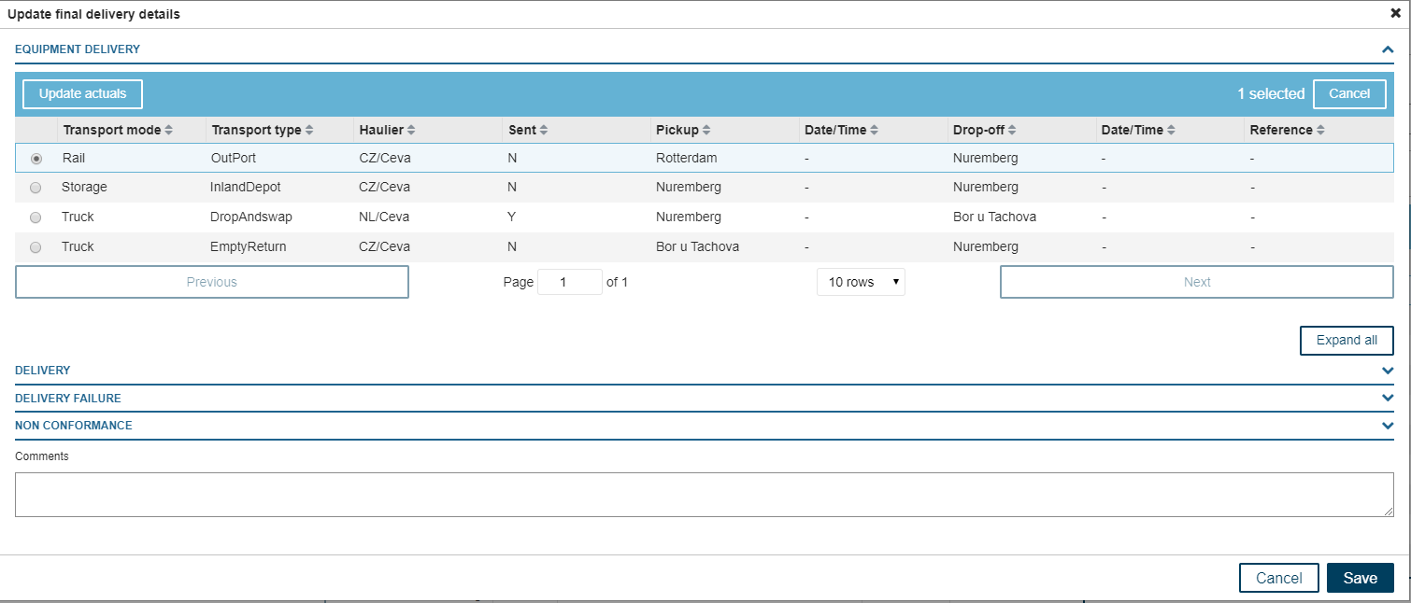

Clicking “Update actuals” (once a record is selected) will show the below screen:

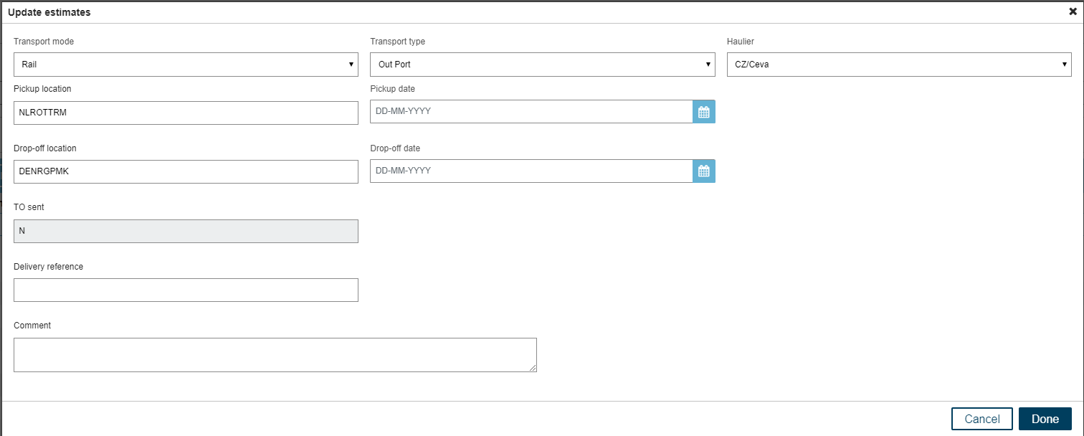

Drop-down values:

1. Transport Mode: Truck, Barge, Rail, Storage
2. Transport Type: transport type are unique per transport mode.

| **Transport Mode** | **Transport Type** |
| --- | --- |
| Truck | Gas check, Fumigation, Inland Depot, Shunt, Out Port, Drop and swap, LiveTip, MilkRun, Empty return, DeRig, Dark Storage |
| Barge | Out Port, Inland Depot |
| Rail | Out Port, Inland Depot |
| Storage | Inland Depot, Dark Storage, Decon Warehouse, DeRig |

1. Haulier: CEVA, Damco, Maritime Transport

Users want to have a bulk upload functionality via an Excel file where they can update or insert multiple records via one Excel file.

We would like to see:

1. How would you write this as a user story/use case/business scenarios?
2. Include acceptance criteria
3. What questions/clarifications do you need to further ask business, if any?
4. Draft Excel template that you would propose to business
5. Provide any comments/suggestions to improve the scenario presented above

You can use MS Word, Notepad, Excel or similar application.

Candidate Name:Irem Burcin Milli

Date: 13.09.2021

Answers

1- Event storming diagram of use cases for single and bulk update:

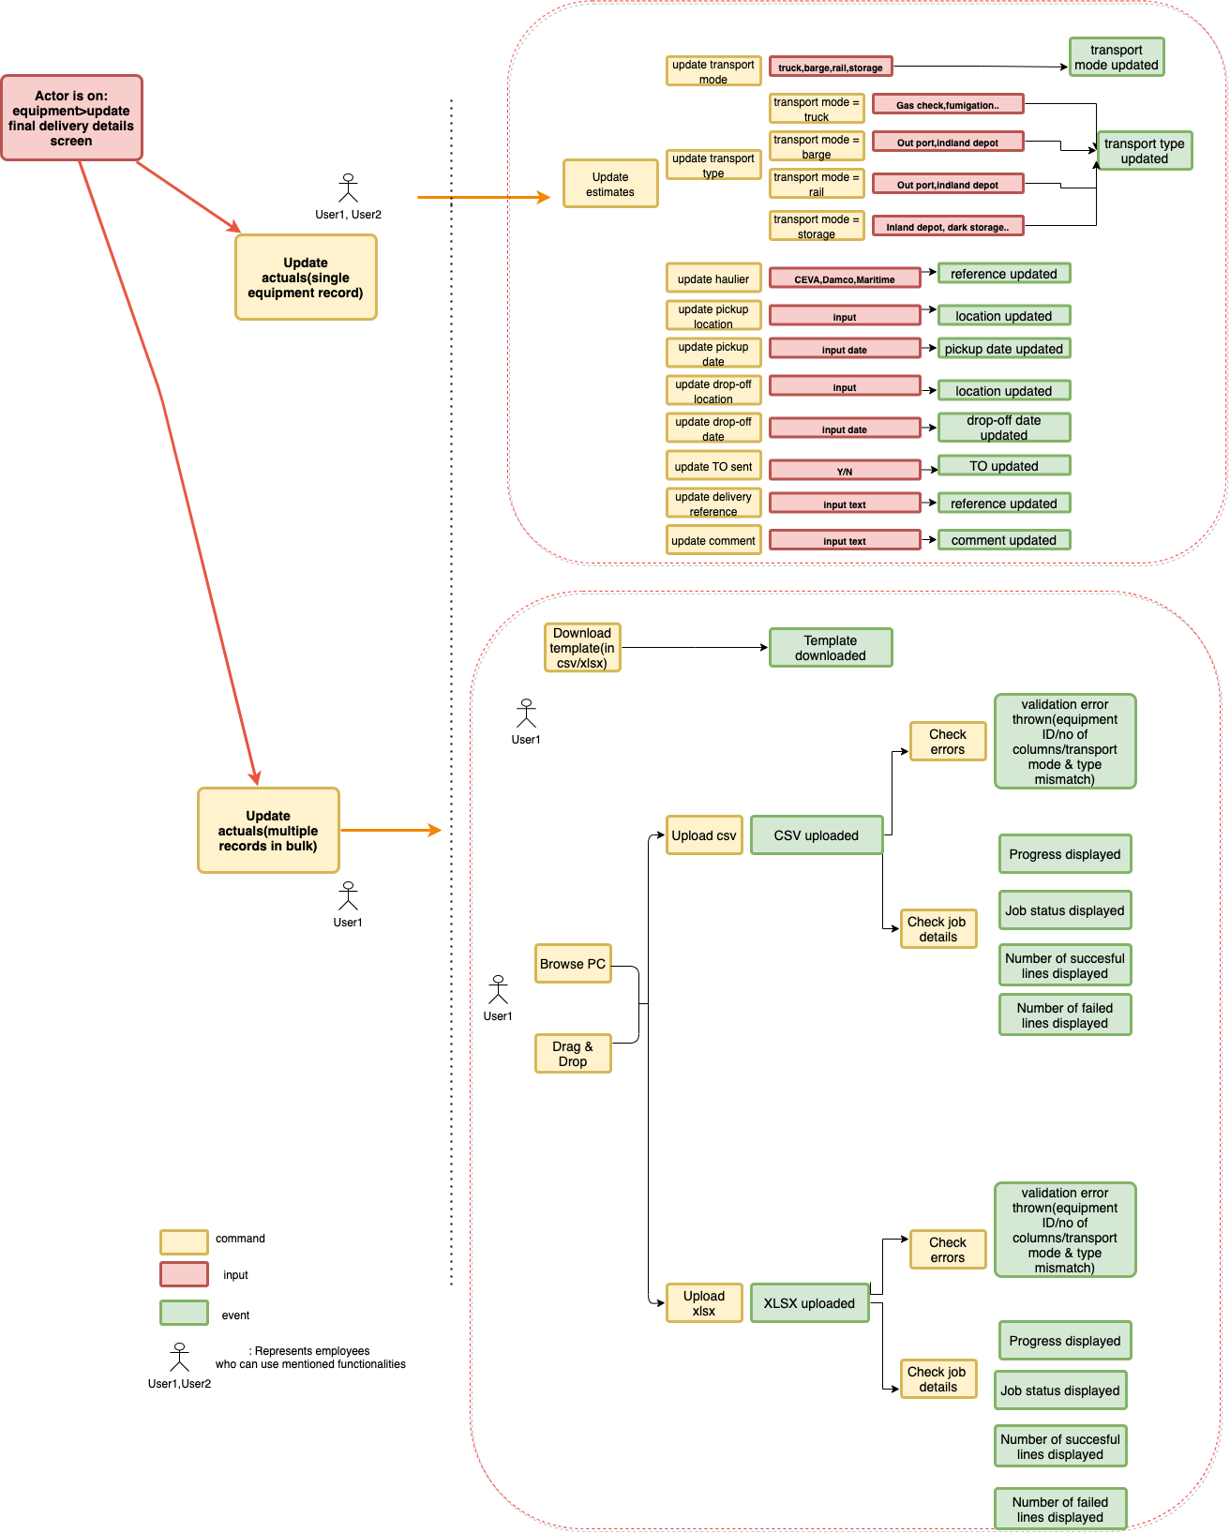

2- User stories and acceptance criteria(some of the requirements added as assumption with relevant AC)

| ReqID | Requirement | User Story | Acceptance Criteria | Scope |
| --- | --- | --- | --- | --- |
| UC1 | Button for bulk upload process should be added to FE | As a user,I would like to have option to bulk update estimates,so that I can perform my tasks efficiently | Given User1 has sufficient permissions  When User1 is on equipment>update final delivery details screen  Then User1 displayed with "Update actuals(multiple records in bulk)" button | MVP |
| UC2 | Functionality to update single equipment estimates via FE screens should be kept available | As a user,I would like to still have the ability to update single record, so that I can | Given User1 has sufficient permissions  When User1 is on equipment>update final delivery details screen  Then User1 both displayed with "Update actuals(multiple records in bulk)" button and "Update actuals(single equipment record)"  And user can perform single updates via screen | MVP |
| UC3 | User should be able to browse/drag and drop the files for upload | As a user, I would like to browse my PC to be able to select the file for upload, so that I can complete the upload process successfully  As a user, I would like to drag & drop file for upload, so that I can complete the upload process successfully | Given User1 is on equipment>update final delivery details screen  When User1 hits "Update actuals(multiple records in bulk)" button  Then User 1 should be able to browse PC folders for file in desired format  And User1 can upload selected file from his/her PC  Given User1 is on equipment>update final delivery details screen  When User1 hits "Update actuals(multiple records in bulk)" button  Then User 1 should be able to drag & drop file in desired format  And User1 can upload selected file from his/her PC via drag & drop | ?? |
| UC4 | User should be able to browse/drag and drop only a single file for upload | As a developer,I would like to limit the file upload to a single file in given format, so that I can ensure the proper process | Given User1 hits "Update actuals(multiple records in bulk)" button  When User1 selected multiple files for upload  Then User 1 should be prompted with an error  And User1 cannot upload multiple files at the same time | MVP |
| UC4 | User should be able to upload file only in csv/xlsx format | As a developer,I would like files to be in defined format, so that I can ensure the proper process | Given User1 hits "Update actuals(multiple records in bulk)" button  When User1 selected xls,txt for upload  Then User 1 should be prompted with an error  And User1 cannot upload formats rather than allowed formats(xlsx,csv) | MVP |
| UC5 | File size should not exceed agreed size | As an analyst,I would like files to be uploaded in agreed size limit, so that I can ensure the performance of the process (e.g 5 MB's) | Given User1 hits "Update actuals(multiple records in bulk)" button  When User1 selected a file exceeding agreed limit(e.g 5 MB's)  Then User 1 should be prompted with an error  And User1 cannot upload the file |  |
| UC6 | All 11 columns should exist in uploaded file | As a user I would like to have all the necessary fields within excel as columns,so that I can access all the fields I can update | Given FileY.csv does contain below columns  |columnno|name |  |1 |EquipmentNumber|  |2 |TransportMode |  |3 |TransportType |  When User1 uploads file  Then User1 gets error "Please upload file in specified format" | MVP |
| UC7 | Transport types should be correctly updated per relevant transport mode | As an analyst, I would like transport mode and type parameters to be updated properly in excel, so that I can make sure of data quality | Given FileY.csv does contain below columns  |transportmode|transporttype|  |truck |Gas check, Fumigation, Inland Depot, Shunt, Out Port, Drop and swap, LiveTip, MilkRun, Empty return, DeRig, Dark Storage|  |barge |Out Port, Inland Depot|  |rail |Out Port, Inland Depot|  |storage|Inland Depot, Dark Storage, Decon Warehouse, DeRig|  When User1 updates transport mode and type  Then User1 gets error "Transport type does not exist for given transport mode" | MVP |
| UC8 | Equipment numbers uploaded should correspond to existing equipment numbers | As a developer I would like to validate the equipment numbers uploaded, so that I can ensure all records updated | Given Equipment with number "ABC1" does not exist  When User1 is has uploaded file with equipment number "ABC1"  Then User1 is displayed with error : "Row:20 Equipment number does not exist"  And User1 is prompted row number information | MVP |
| UC9 | Process status should be visible to users | As a user I would like to see upload status,so that I can be informed on how the process is concluded | Given user uploaded FileX.csv  When user is on bulk upload screen  Then user should be displayed progress in FE and any of the status  |Initiated |  |Running|  |Failed | | MVP |
| UC10 | Details of updated lines should be displayed to user | As a user I would like to details of successful and failed lines in uploaded file, so that I can be well informed | Given FileX.csv having 15 rows and is successfully processed  When user is on bulk upload screen  Then user should be displayed  File |Numberofsuccesfulrows |Numberoffailedrows|  FileX.csv |10 |5 |  And user should have details on failed rows  |Failedrowno |  |1,4,5,12,13 | | ?? |
| UC11 | Upon process has been finished,user should be notified | As a user I would like to be notified when update process is finished,so that I can be informed from finished processes | Given user successfully uploaded FileX.csv  When upload job is finished  Then user should be prompted a notification in FE | ?? |
| UC12 | Bulk update functionality should be performed only by users having certain role | As a stakeholder, I would like only some users having the bulk upload functionality, so that I can utilise performance of the platform and limit operation to privileged role | Given User2 has NO sufficient permissions  When User2 is on equipment>update final delivery details screen  Then User2 should not be displayed with "Update actuals(multiple records in bulk)" button  But User 2 should be displayed "Update actuals(single equipment record)"  And User 2 can perform single updates via screen | ?? |
| UC13 | Template having pre-built validations should be able to downloaded | As a user, I would like to have option to download the excel templates for upload, so that I can ensure I will upload the files in proper format | Given User1 is on equipment>update final delivery details screen  When User1 hits "Download template" button and selects a format  Then User 1 should be able to download template in desired format(csv,xlsx)  And User1 can fill in downloaded file | ?? |
| UC14 | Templates should have pre-built data validations | As a stakeholder/analyst, I would like to have the data validation built in on the downloaded excel templates, so that I can ensure the file format beforehand | Given User1 have downloaded Template_xlsx1.xlsx  When User1 fills in Transport Mode  Then User1 should be prompted with validation list : Barge,Truck,Rail,Storage  Then User 1 should be able to download template in desired format(csv,xlsx)  And User1 can fill in downloaded file  Given User1 have downloaded Template_xlsx1.xlsx  When User1 fills in "Sent" column  Then User1 should be prompted with validation list : Y,N  Given User1 have downloaded Template_xlsx1.xlsx  When User1 fills in "Haulier" column  Then User1 should be prompted with validation list : Ceva,Damco,Maritime  Given User1 have downloaded Template_xlsx1.xlsx  When User1 fills in columns with dates(drop off dat, pickup date)  Then User1 should be prompted with data validation on proper date format and validity | MVP |

3- Questions to business to further clarify:

Q1: What are the file formats business would like to have in bulk upload? csv,xlsx..?

Q2: Due to performance concerns, we’d need to limit the number of lines(or file size) in the single upload process. What could be a reasonable limit, based on the business need of this functionality? (later on to be checked w development team as well)

Q3: What would be the daily limit on the bulk upload process per user? (we would not want process to be abused by users)

Q4: Would you like to limit this functionality for the use of certain roles/roles only? Would we need to create a new role/permission to be able to use “bulk upload” functionality?

Q5: Should bulk upload process stop when any of the lines in uploaded excel failed to be updated? Or would you prefer to have the process running and report failed lines to the user after the process?

Q6: Depending on the technical/architectural db setup, we’d need to pause the subsequent updates(e.g if there is a running bulk upload process, an upload on estimates cannot be performed by other users).

Q7: Would you like to have in the future, audit possibilities on this functionality(e.g user name, uploaded file name, updated lines,date..)

Q8: Should user be notified when the background update process is finished?

Q9: What could be the character limit of the “delivery reference” and “comment” fields? Do they accept special characters etc?

Q10: Would users prefer drag & drop or would they like to have browse PC option when selecting a file for upload?

4. Draft Excel template

https://docs.google.com/spreadsheets/d/15qdKu9lC9m9YNme2NcQz36kvZtwW48nMmsABDwseHtY/edit?usp=sharing

5- Comments/suggestions to improve the scenario presented above

1- I would propose to display details of the bulk upload process:

* Job status: Initiated,running, failed,suspended
* Progress(when status is running): %80…
* Time elapsed: Time have been passed since job has been initiated by user
* Number of lines uploaded
* Number of lines failed(equipment ID for the failed lines)
* Number of successful lines

2- We could show the details of the failed records for better UX on this process, so that users can find the failed records and update those lines via single/bulk operation again.

3- As mentioned in Q7 and also above,perhaps after mvp I’d also research the need of auditing/version history with business on whether this is a functionality which is in heavy daily use by many users.So that this functionality can be added.

4- (depending on user group’s need) I would add an epic to team’s backlog for ready-bulk upload template in desired format(csv,xlsx) and a download functionality for this, so that a new user can benefit from downloading the file and using the file directly.(Until then template can be provided manually e.g via email)

5- I would also add an epic on the team's backlog to have a pre-validation on the equipment ID and also validation for transport mode vs transport type matches. (Until then, a template with excel data validation can be used)